Drew Dickson

Final Project

Back-End Course June 2023

**UNIVERSITY CLASS ENROLLMENTS**

**Executive Summary:**

This project is intended to catalog the class enrollment of students and professors at a university. Students are constantly adding and dropping classes at universities for a variety of reasons. The point of this is to create a way to update class rosters in real time with changes in enrollment. With this project, school administrators and faculty will be able to accurately account for enrollment while having the flexibility to make updates.

**Initial Features:**

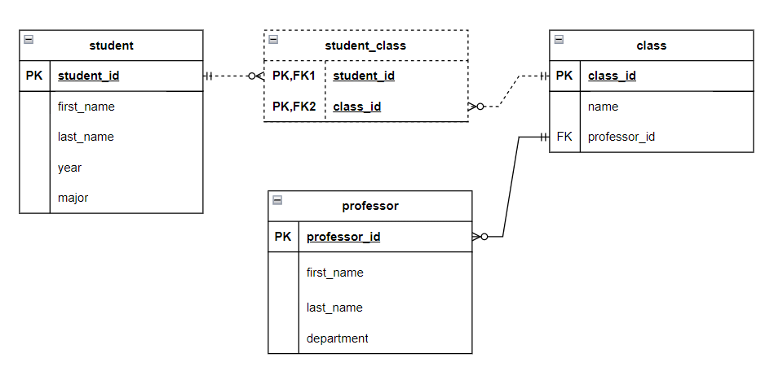

* ENTITY: Students, Class, Professor
* Pull all students (GET)
* Enroll a new student (POST)
* Update a student’s profile (PUT)
* Remove a student (DELETE)
* Hire a new professor (POST)
* Drop a course (DELETE)

**Stretch Goals (to be completed if time allows, or after graduation):**

* Retrieve classes taken by student’s major.
* Retrieve classes taken by professor’s department.
* If a major is dropped by the university, reassign those students to undeclared.
* Be able to remove students from all classes after their senior year.